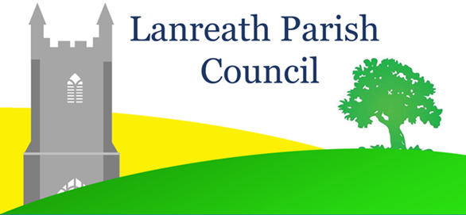
COVID Safe Procedure
for the Conduct of Face-to-Face Meetings of the
Parish Council
The interim legislation that allowed for meetings to be held remotely during the Covid 19 pandemic has lapsed and, under the Local Government Act 1972, future meetings of the Parish Council are required to held face-to-face. Members of the public and press have a statutory right to attend meetings of the Parish Council as observers.
Parish Council meetings will be held in accordance with the latest Government regulations and guidance on preventing the spread of Covid 19. As from the 17th of May 2021 it is anticipated that a much greater range of indoor activity can resume in line with the Roadmap set out by the government on 22 February. This includes activities which are likely to have comparable health risks to local authority meetings, for example allowing up to 1,000 people to attend performances or sporting events in indoor venues, or up to half-capacity (whichever is lower).
To ensure the safety of the Council and attending members of the public, and following completion of a risk assessment, the following procedures will apply to all Parish Council Meetings until further notice.
- Meetings will be held in the main Village Hall and not in the Meeting Room.

- All hard surfaces such as door handles, chairs, tables, light switches and wash basins will be cleaned with sanitiser wipes before and after the meeting.

- All persons attending the meeting are required to maintain social distancing on entering and leaving the hall and throughout the meeting.

- All persons attending the meeting are requested to wear face masks. Rather than attending in person, members of the public who are unable to wear face coverings for health reasons are requested to submit any queries or observations that they may wish to raise with the Parish Council by contacting the Parish Clerk, Rebecca Warren clerk2lanreathpc@gmail.com or via the ‘Contact Us’ facility on the Parish Council website.

- Hand sanitiser will be provided in the entrance lobby and in the hall. Attendees are requested to use hand sanitiser prior to entering the hall.

- Seats will be located at least 2 metres apart and arranged so that no chair faces another.

- Windows and external doors will be left open during the meeting to the extent permitted by the prevailing weather conditions.

- No more than two persons to use each suite of toilets at one time

- There will be no shared paperwork at the meeting; the agenda and any relevant Planning documents under consideration will be available to view via a projector.

- Hand sanitiser to be used before councillors sign the Acceptance of Office Register or other statutory documentation at a separate table using their own pens.

- No person may attend a Parish Council meeting if they or their households have developed Covid 19 symptoms or had a positive Covid test within the last 10 days.

- Those wishing to attend who have not had at least one Covid vaccination or have been classed as clinically extremely vulnerable by their GP should consider submitting queries / observations on agenda items or other issues by email to the Parish Clerk ahead of the meeting rather than attending in person.

- To ensure adequate safe distancing during the meeting, the number of members of the public attending the meeting is limited to 12. To avoid having to turn away members of the public on the day, those wishing to attend a given meeting are requested to advise the Parish Clerk by email ahead of the meeting.

- For the protection of those who may use the hall subsequently, anyone displaying Covid symptoms or who has a positive Covid test within 7 days of attending a meeting to inform the Parish Clerk.

